Plant a Hope 3.0

“Who Plants a Tree Plants a Hope”

Just about 21% of the chemical component of air is oxygen. Nonetheless, it is important to life on Earth. From single-celled species to humans, oxygen is used to provide the energy needed to keep them alive. In response to this, Leo Club of University of Colombo initiated the project “Plant a Hope 3.0” for the third consecutive time under project category of “Environment” for leostic year 2020/2021. Plant a Hope 3.0 is a project that we are working on increasing the Earth's green cover. Plant a Hope 3.0 would be a successful forum to inspire the society to conserve trees in order to keep the Earth green, as deforestation is a major issue in Sri Lanka.

**Project Details**

**Project Title** - Plant a Hope 3.0

**Project Category -** Environment

**Project Chairperson** - Leo Chanaka Wickramasinghe

**Project Secretary** - Leo Medani Gunathilaka

**Project Treasurer** - Leo Anuradha Wickramasinghe

**Date -** Phase 1- 22nd of April 2021

**Time -** Phase 1- 8.00 a.m to 2.00 p.m

**Venue -**  Phase 1-Hanthana Reservation Area in Kandy

**Project Execution**

Phase 1

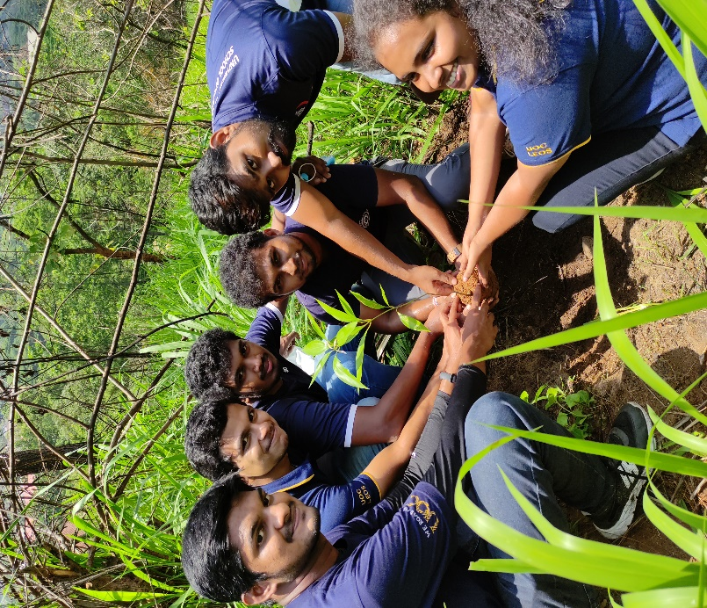Trees benefit the ecosystem by supplying oxygen, improving air quality, reducing climate change, conserving water, and protecting soil. Photosynthesis is the mechanism by which trees take in carbon dioxide and provide oxygen for us to breathe. However, the majority of deforestation occurs in the tropics today. With the construction of new roads through the dense forests, previously inaccessible areas are becoming available.

Plant a Hope 3.0 was released on 22nd of April 2021 at Hanthana reservation area from 8.00 a.m. with the intention of making the planet greener. We collaborated with five societies of university of Colombo: Hanthana Conservation Society, Green Heart Society, Rotract Club of University of Peradeniya, Explorer’s Club and Agriculture Faculty Forestry Society to make our project more effective and efficient. We prepared the land and planted nearly 400 plants thanks to our fruitful partnership. These plants were discovered, which had been purchased from the Mahaweli Development Authority and donated by individuals. We were funded by Nugasewana Agro Fram, a modern Sri Lankan agriculture cyber brand, to help make our project a success.

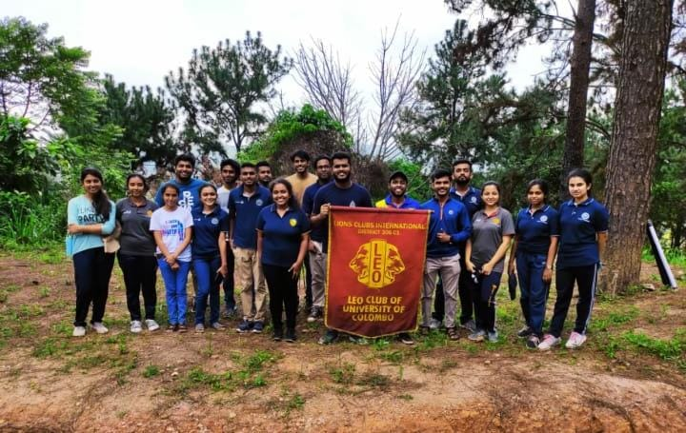The phase was over with Leo Medani Gunathilaka giving a vote of thanks to Mr. Upul B. Dissanayaka, the vice chancellor of the University of Peradeniya, for granting permission and other supporters. Finally University of Colombo Leos were able to remind everyone that "Reversing deforestation is complicated, but planting a tree is easy".

**Financial Report**

**Income and Expenditure Account**

|  |  |  |  |  |
| --- | --- | --- | --- | --- |
| **Description** | **Note** | **Value** | **Cash/Bank** | **Admin/Project Account** |
| **Income** |  |  |  |  |
| Donations from outsiders |  | 2000.00 | Cash |  |
| Donations from club members |  | 2550.00 | Cash |  |
| Donations from committee members |  | 1960.00 | Cash |  |
| Club |  | 2000.00 | Cash |  |
| Sponsorships |  | 30000.00 | Bank |  |
| **Total Income** |  | **11510.00** |  |  |
| **Expenditure** |  |  |  |  |
| **Phase 1** |  |  |  |  |
| Plants |  | 3150.00 | Cash |  |
| Printouts |  | 220.00 | Cash |  |
| Lunch |  | 4800.00 | Cash |  |
| Transportation |  | 1000.00 | Cash |  |
| Refreshments |  | 2340.00 | Cash |  |
| **Total Expenditure** |  | **11510.00** |  |  |

**Conclusion & Acknowledgement**

Project Plant a Hope 3.0 which was initiated under the category of Environment is believed to achieve tremendous success. The plans and objectives of the project were achieved. The plans and objectives of the project were achieved with the support of many people including the members of the club and all the best affairs. They were designed under different stages and were properly executed with great support from committee members.

Firstly, the project committee would like to thank the club president of Leo Club of University of Colombo Leo Nipuna Sandaruwan, Vice president Leo Sahan Nagahawatta, Club secretary Leo Nimesh Henadeera for guiding the project planning, reporting, incentive responses, and valuable suggestions throughout the project.

This would not have been successful without the massive support of the Vice Chancellor of University of Peradeniya Professor Upul B.Dissanayaka. Especially mention should be made towards the contribution we received from curator of University of Peradeniya Mr.Ananda.

A special thank goes to Professor Nishshanka for the immense support given. Special thank also goes to Nugasewana Agro Farm, a modern Sri Lankan agriculture cyber brand, who helped to donated monitory make our project a success. Thanks goes project committee members, and the club members for the immense support that they are given to the phase.

The project would not have been successful without the massive support of the five volunteering clubs of university of Peradeniya namely Hanthana Conservation Club, Green Heart Society, Explorer’s Club, Agricultural faculty Forestry Society and Rotaract Club of University of Peradeniya.

Not only that we would like to thank the Mahaweli Development Authority for providing us with valuable plants.

The information technology unit created all the event flyers and videos. The public relations unit posted all the flyers and videos on social media platforms. All the club members shared and liked the event flyers through social media platforms and assisted in gaining publicity during the project phase.

The non-leo students of University of Colombo School of Computing provided us a massive support to make this event a success. Without them this project would not have been successful.

With that Plant a Hope 3.0, the project was successfully concluded by the Leo Club of University of Colombo with the unconditional support provided by the club members.